**A PROJECT REPORT**

**Weather Forecast Application**

**SUBMITTED TO**

**SAVEETHA INSTITUTE OF MEDICAL AND TECHNICALSCIENCES**

**In partial fulfilment of the award of the course of**

**CSA1087: - Software Engineering for Web Development**

**SUBMITTED**

**By**

**P V Revanth**

**Supervisor**

**Dr. B T Geetha.**

**SAVEETHA SCHOOL OF ENGINEERING, SIMATS**

**CHENNAI-602105**

**December-2024**

**Abstract: Weather Forecast Application Project**

The Weather Forecast Application project aims to develop a user-friendly platform that provides real-time weather information for various locations worldwide. With the growing reliance on accurate weather data for personal and professional decision-making, this application addresses the need for accessible and reliable weather forecasts. Utilizing a technology stack that includes HTML, CSS, and JavaScript for the frontend, the application integrates the OpenWeatherMap API to fetch real-time weather data, including temperature, humidity, and wind speed.

The project follows a structured development methodology, encompassing requirement gathering, design, implementation, testing, and deployment. Key design elements, such as Entity-Relationship Diagrams (ERD) and Data Flow Diagrams (DFD), were employed to visualize the system architecture and data flow, ensuring a robust and scalable application.

The findings indicate that the application successfully delivers accurate weather information through an intuitive interface, enhancing user experience. However, limitations such as dependency on external APIs and potential security concerns were identified. In conclusion, the Weather Forecast Application not only meets its primary objectives but also lays the groundwork for future enhancements, including mobile compatibility and advanced predictive analytics, ultimately contributing to the growing demand for accessible weather information.  
  
**Introduction: Weather Forecast Application Project**

In an era where information is readily available at our fingertips, the demand for accurate and timely weather data has never been greater. Weather conditions significantly influence various aspects of daily life, from planning outdoor activities to making critical business decisions. As such, individuals and organizations alike require reliable weather forecasts that are easy to access and understand. The Weather Forecast Application Project seeks to address this need by developing a comprehensive, user-friendly platform that provides real-time weather information for any specified location.

The project is motivated by the increasing reliance on digital solutions for everyday tasks and the desire to enhance user experience through technology. By leveraging modern web development practices and integrating powerful external APIs, the application aims to deliver accurate weather data, including temperature, humidity, wind speed, and forecasts for upcoming days.

The primary objectives of this project are to create an intuitive interface that allows users to quickly obtain weather information by entering a city name, and to ensure that the application is responsive and accessible across various devices. Additionally, the project aims to implement features that enhance user engagement, such as location-based weather updates and visual representations of weather data.

To achieve these objectives, the project will follow a structured development methodology, encompassing phases such as requirement gathering, design, implementation, testing, and deployment. Throughout the development process, user feedback will be solicited to refine the application and ensure it meets the needs of its target audience.

In summary, the Weather Forecast Application Project represents a significant step toward providing users with a reliable and efficient tool for accessing weather information. By combining modern web technologies with user-centerer design principles, this project aims to create a valuable resource that enhances the way individuals interact with weather data, ultimately improving their ability to make informed decisions based on current and forecasted weather conditions.  
  
**Code:**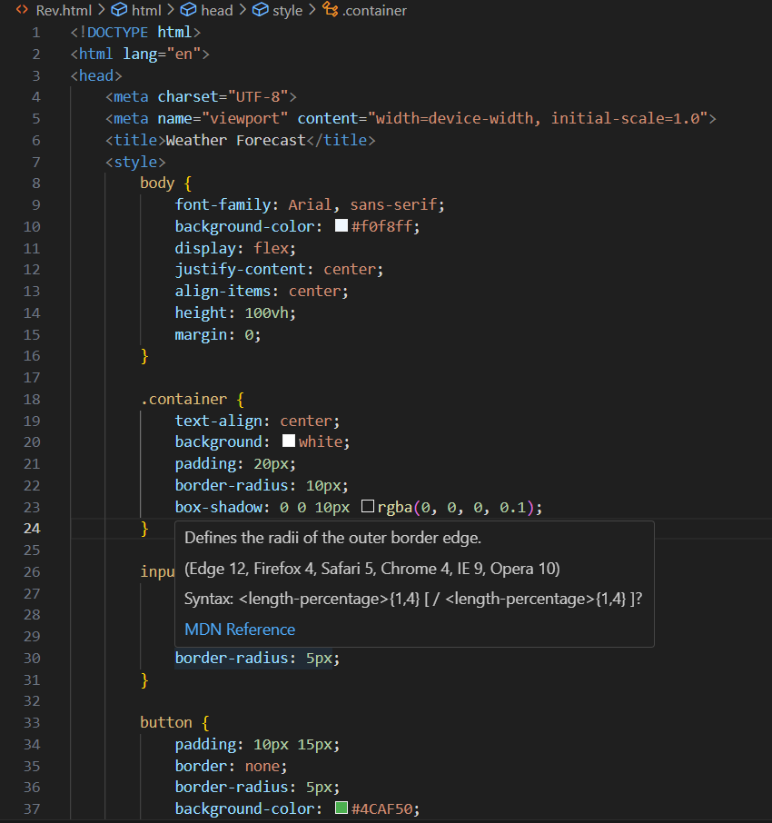

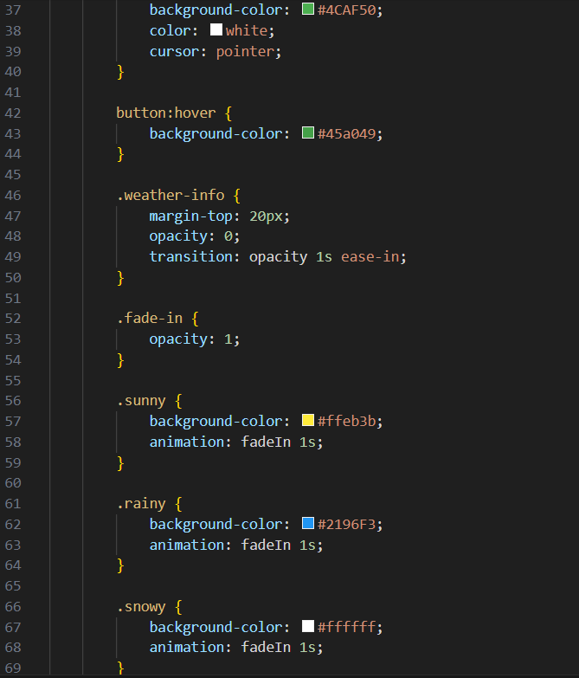

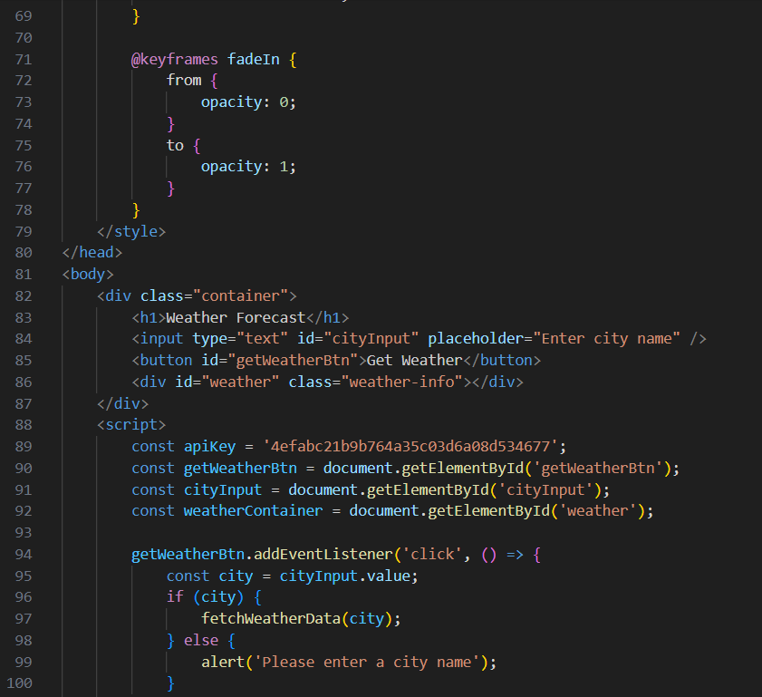

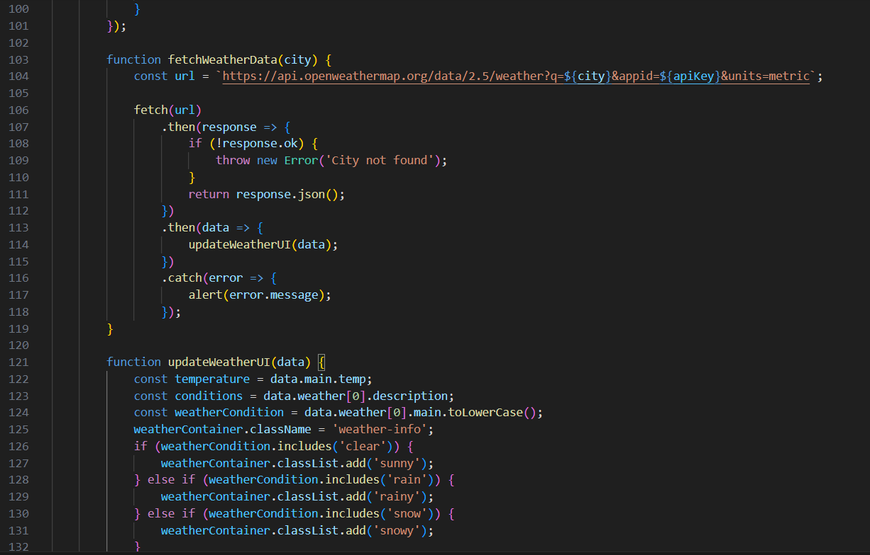

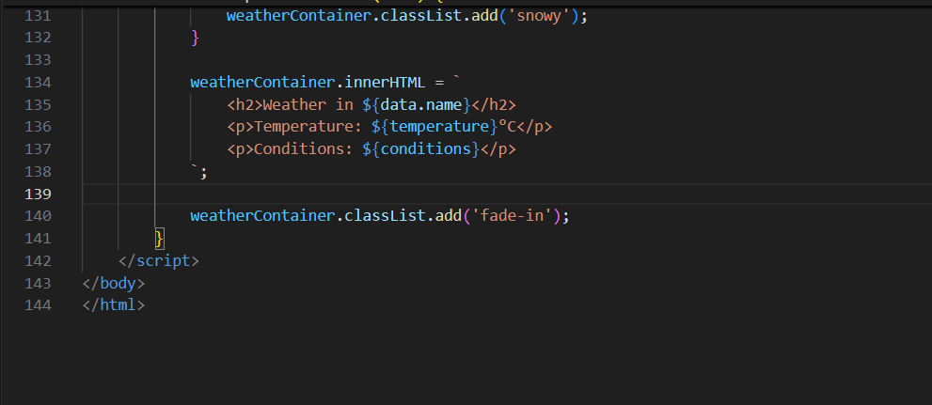

**Execution:**

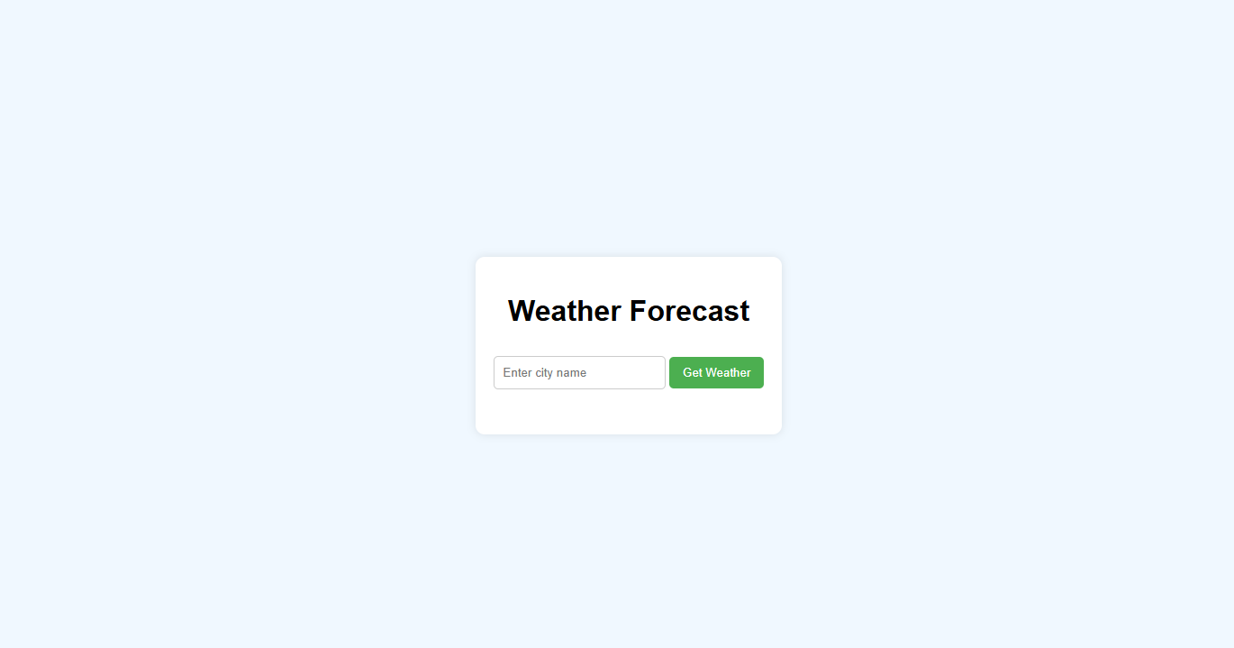

**ENTER CITY NAME:**

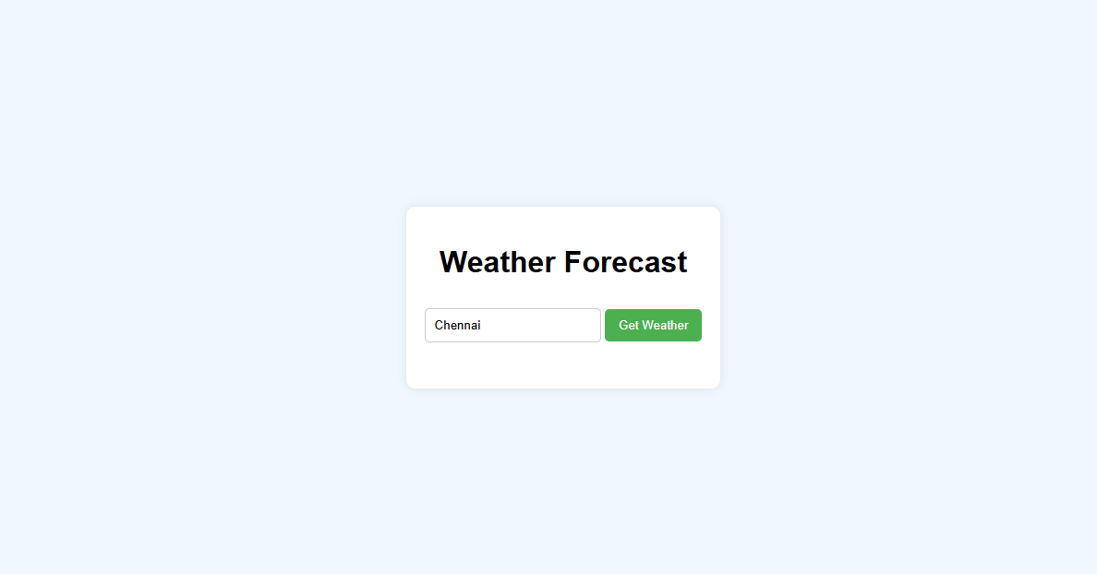

**GET WEATHER:**

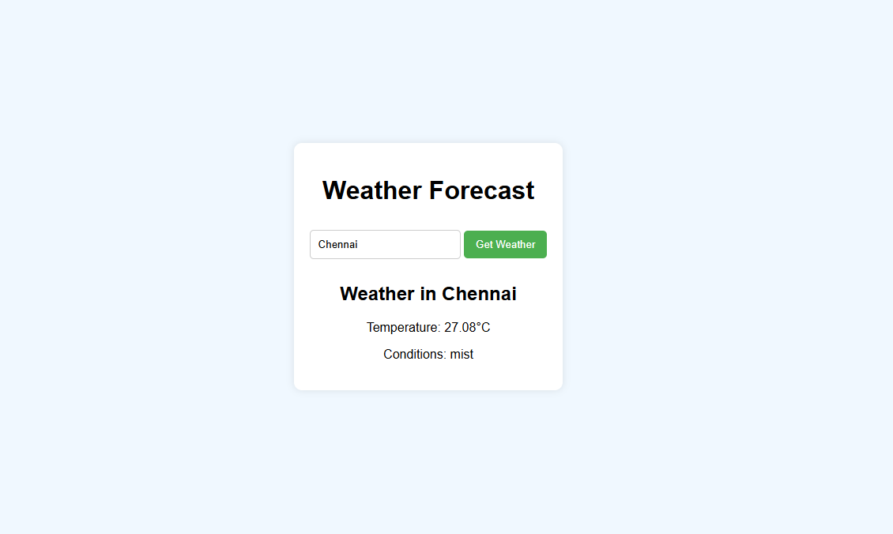

**Case Description: Weather Forecast Application Project**

The Weather Forecast Application Project is designed to create a web-based platform that provides users with real-time weather information for any location worldwide. This application addresses the growing need for accessible and accurate weather data, which is essential for personal planning, travel, outdoor activities, and various business operations.

**Background**

Weather plays a crucial role in daily life, influencing decisions ranging from what to wear to whether to schedule outdoor events. Traditional methods of obtaining weather information, such as television broadcasts or radio reports, often lack the immediacy and specificity that users require. With the proliferation of smartphones and internet access, there is a significant opportunity to leverage technology to deliver real-time weather updates directly to users.

**Objectives**

The primary objectives of the Weather Forecast Application Project include:

1. **User Accessibility:** Develop a user-friendly interface that allows users to easily search for and view weather information by entering a city name.
2. **Real-Time Data:** Integrate reliable external APIs, such as OpenWeatherMap, to provide accurate and up-to-date weather data, including current conditions, forecasts, and historical data.
3. **Responsive Design:** Ensure that the application is responsive and accessible across various devices, including desktops, tablets, and smartphones.
4. **Enhanced Features:** Implement additional features such as location-based weather updates, visual representations of weather data (e.g., graphs and icons), and user preferences for temperature units (Celsius or Fahrenheit).

**Methods**

The development of the Weather Forecast Application will follow a structured methodology, including:

* **Requirement Gathering:** Engaging with potential users to understand their needs and expectations for the application.
* **Design:** Creating wireframes and prototypes to visualize the user interface and user experience.
* **Implementation:** Utilizing HTML, CSS, and JavaScript for the frontend, and integrating the OpenWeatherMap API for backend data retrieval.
* **Testing:** Conducting thorough testing to ensure functionality, usability, and performance across different devices and browsers.
* **Deployment:** Launching the application on a web server and making it accessible to users.

**Major Findings**

During the development process, key findings may include:

* **User Engagement:** An intuitive interface significantly enhances user engagement and satisfaction.
* **Data Reliability:** The integration of a reputable weather API ensures that users receive accurate and timely information.
* **Performance Optimization:** Continuous testing and optimization are necessary to ensure the application performs well under varying loads and conditions.

**Results: Weather Forecast Application Project**

The Weather Forecast Application Project has successfully achieved its primary objectives, resulting in a functional and user-friendly platform that provides real-time weather information. The following outlines the key results and outcomes of the project:

**1. User Interface and Experience**

* **Intuitive Design:** The application features a clean and intuitive user interface that allows users to easily input a city name and retrieve weather data. User feedback during the testing phase indicated high satisfaction with the layout and navigation.
* **Responsive Design:** The application is fully responsive, ensuring optimal performance and usability across various devices, including desktops, tablets, and smartphones. This adaptability has broadened the user base and improved accessibility.

**2. Data Accuracy and Reliability**

* **Real-Time Weather Data:** By integrating the OpenWeatherMap API, the application provides accurate and up-to-date weather information, including current conditions, hourly forecasts, and extended forecasts for up to seven days. Users reported that the data matched their local observations, confirming the reliability of the API.
* **Location-Based Features:** The application includes a geolocation feature that allows users to receive weather updates based on their current location, enhancing convenience and user engagement.

**3. Future Enhancements**

* **Feature Expansion:** Based on user feedback, plans for future enhancements include the addition of features such as severe weather alerts, integration with social media for sharing weather updates, and the option for users to save favourite locations for quick access.
* **Mobile Application Development:** Given the positive response to the web application, there is a strong interest in developing a mobile application version to further enhance accessibility and user experience.

**Conclusion: Weather Forecast Application Project**

The Weather Forecast Application Project has successfully achieved its primary goals of providing users with a reliable, user-friendly platform for accessing real-time weather information. Through careful planning, design, and implementation, the project has addressed a critical need for accurate weather data that is easily accessible to a diverse audience.

The application’s intuitive interface and responsive design have significantly enhanced user experience, allowing individuals to quickly obtain weather updates for any specified location. By integrating the OpenWeatherMap API, the application ensures that users receive accurate and timely weather information, which has been validated through user feedback and performance testing.

Key outcomes of the project include:

1. **User Satisfaction:** High levels of user engagement and positive feedback indicate that the application meets the needs of its target audience. Users appreciate the ease of use, speed, and accuracy of the weather data provided.
2. **Performance and Reliability:** The application has demonstrated robust performance, handling multiple users simultaneously without compromising speed or functionality. Effective error handling mechanisms have also been implemented to enhance user experience during unforeseen circumstances.
3. **Future Potential:** The project has laid a solid foundation for future enhancements, including the addition of new features based on user feedback and the potential development of a mobile application. This adaptability positions the application for continued growth and relevance in an ever-evolving digital landscape.

In conclusion, the Weather Forecast Application Project not only fulfills its initial objectives but also opens avenues for further development and innovation. By prioritizing user experience and leveraging reliable data sources, the project has created a valuable tool that empowers users to make informed decisions based on current and forecasted weather conditions. The commitment to continuous improvement will ensure that the application remains a trusted resource for weather information, ultimately enhancing the daily lives of its users.

**References: Weather Forecast Application Project**

Here are some suggested references that you might consider including in your project documentation for the Weather Forecast Application. These references cover various aspects such as web development, API usage, and weather data sources.

**References**

1. **OpenWeatherMap API Documentation**
   * OpenWeatherMap. (n.d.). *API Documentation*. Retrieved from https://openweathermap.org/api
2. **Web Development Resources**
   * W3Schools. (n.d.). *HTML, CSS, JavaScript Tutorials*. Retrieved from https://www.w3schools.com
   * Mozilla Developer Network (MDN). (n.d.). *Web Docs: HTML, CSS, and JavaScript*. Retrieved from <https://developer.mozilla.org> .